Contents
Feedback for Datafeed ConfigHQ Overview 2
Feedback Example: 3
Service Delivery Feedback: 5
Support Feedback: 6
Other Feedback Comments: 7

Feedback for Datafeed ConfigHQ Overview
New feedback link.
Goal: To hopefully shut down Swift UI Datafeed, and transition Service Delivery and Customer Support to ConfigHQ Datafeed.
Purpose of this document: What are needs & nice to haves for Datafeed ConfigHQ for Service Delivery and Support.
Luciano Assumptions and questions:
- Service Delivery: 99% of Datafeed is created by service delivery and never touched again.
  - Customers just setup some type of automation on their side.
  - Common questions:
    - Did the test Datafeed upload file, was it successful?
- Support: Just passes questions from customers to the PM to debug.
  - Not sure if the support team tests to see if they are able to replicate the issue.
  - What kind of questions does support ask to investigate a bit more?
  - What are the most Common support questions for Datafeed do you see?
  - Where does support go to investigate? Is there a Datafeed document that you reference? Do you check honeycomb? Etc.
  - Does support use or even have access to ConfigHQ?
  - Are there ideas that could help support be more independent that doesn’t make support dependent on PM & engineering team?
Feedback:
- Screenshot of potential “improvement”
- Why you would want that.
- Name
Other Feedback Comments (At the bottom):
- Write your problem and why.
- Name.

Feedback Example:
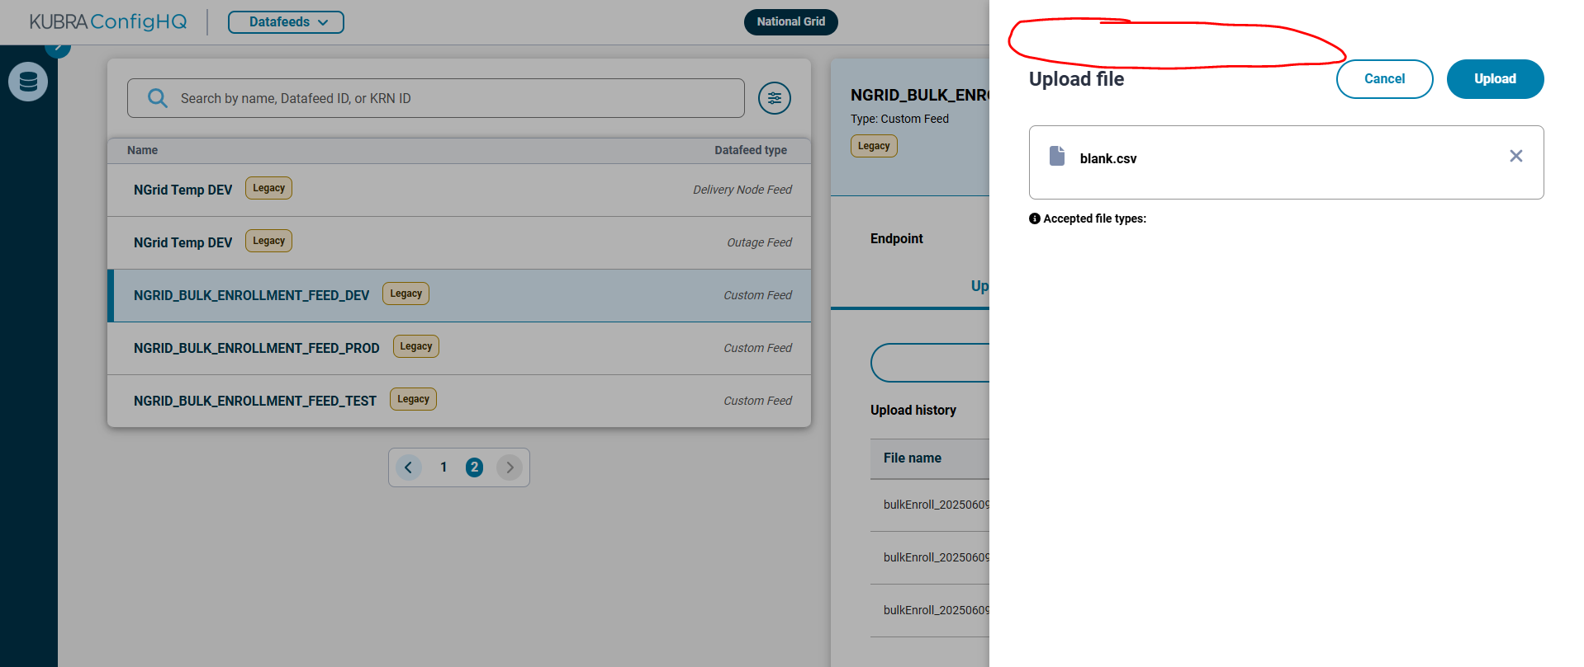
- Who: Casey Hornbeck
- What & why: nice to have would be including the Datafeed name in the upload window that pops up. can be a little hairy trying to make sure you are uploading files to the correct feed, mostly a concern we didn’t accidentally click the prod feed
Completed: Aug 19th.
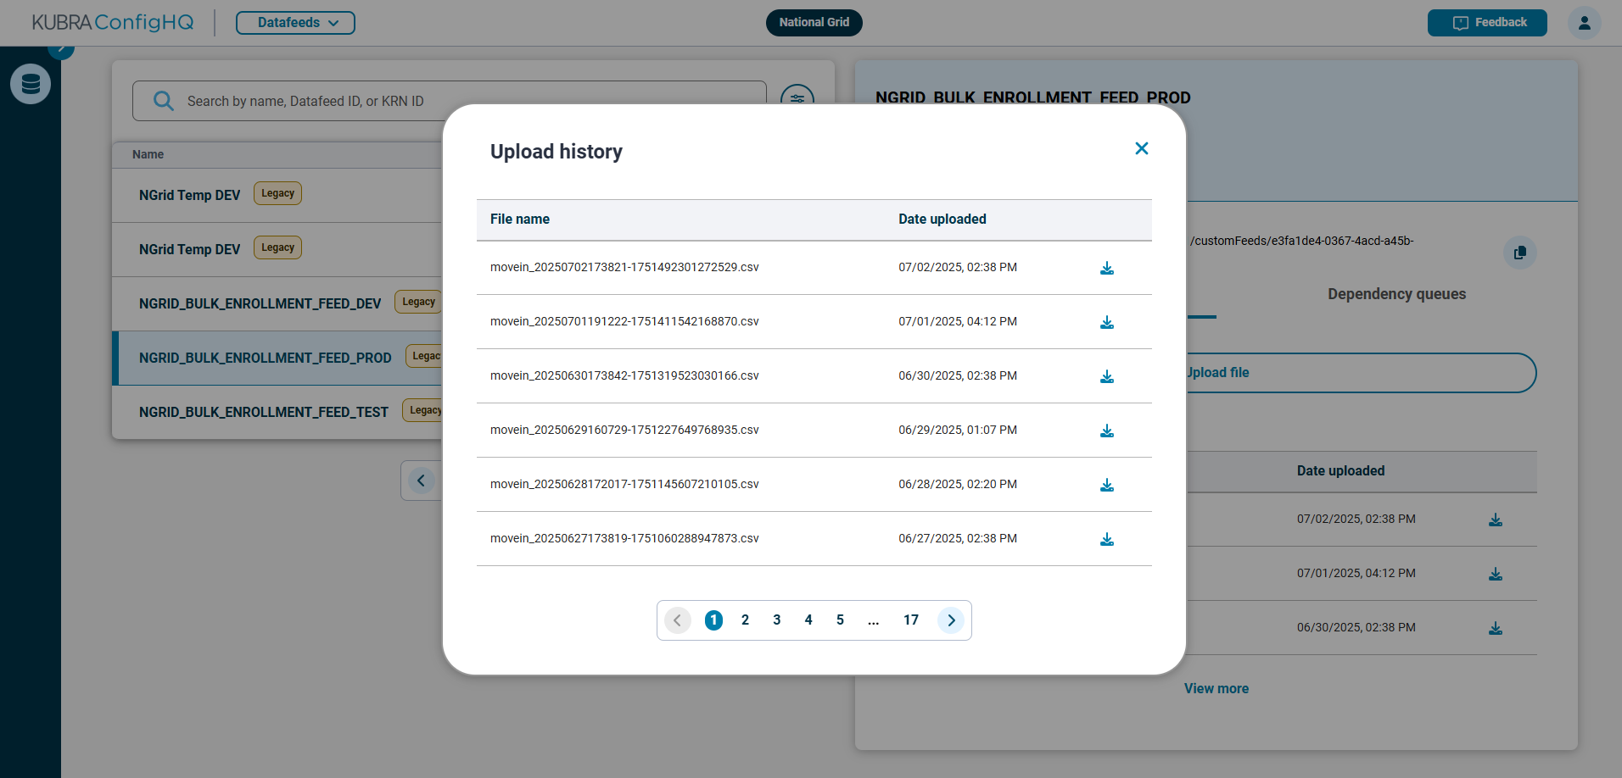
- Who: Casey Hornbeck
- What & why: Being able to filter and search (for eg. by date and time) for files through this UI would be MUCH easier than going to the underlying s3 bucket in aws and trying to find the files there
Complete: Aug 14th.

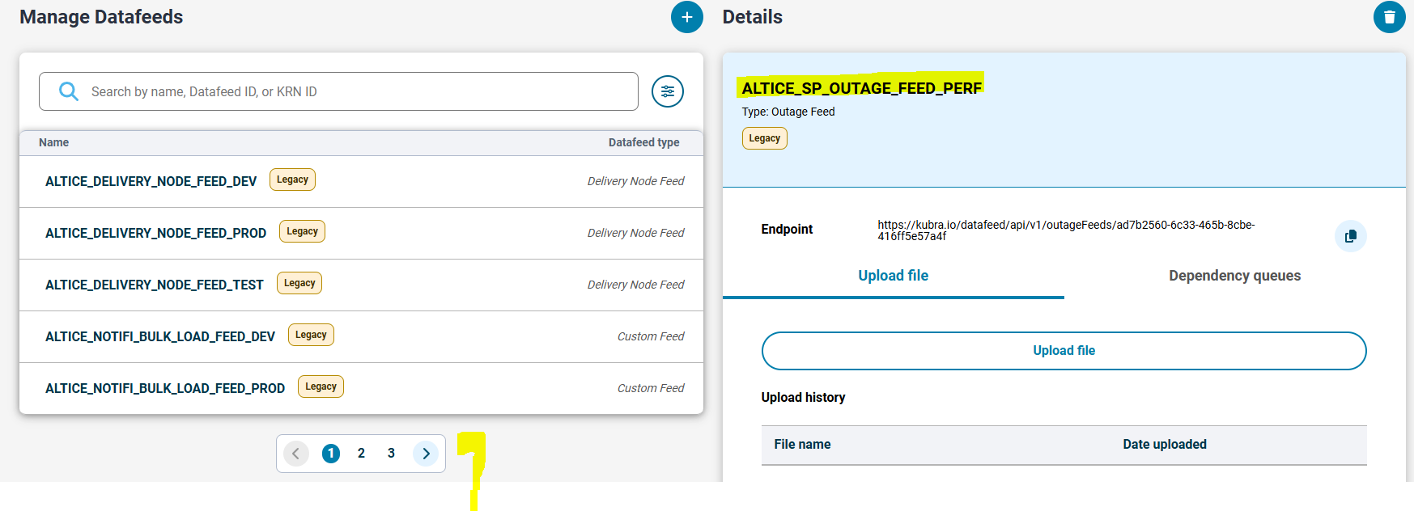
- Who: Saloni Goyal
- What & Why: sometimes we need to manually search for the name of the feed as it's not present on any of the pages as shown. If we don't know the name of the feed, we cannot see it in the list even if it's there.
Complete: Aug 14th.

Service Delivery Feedback:

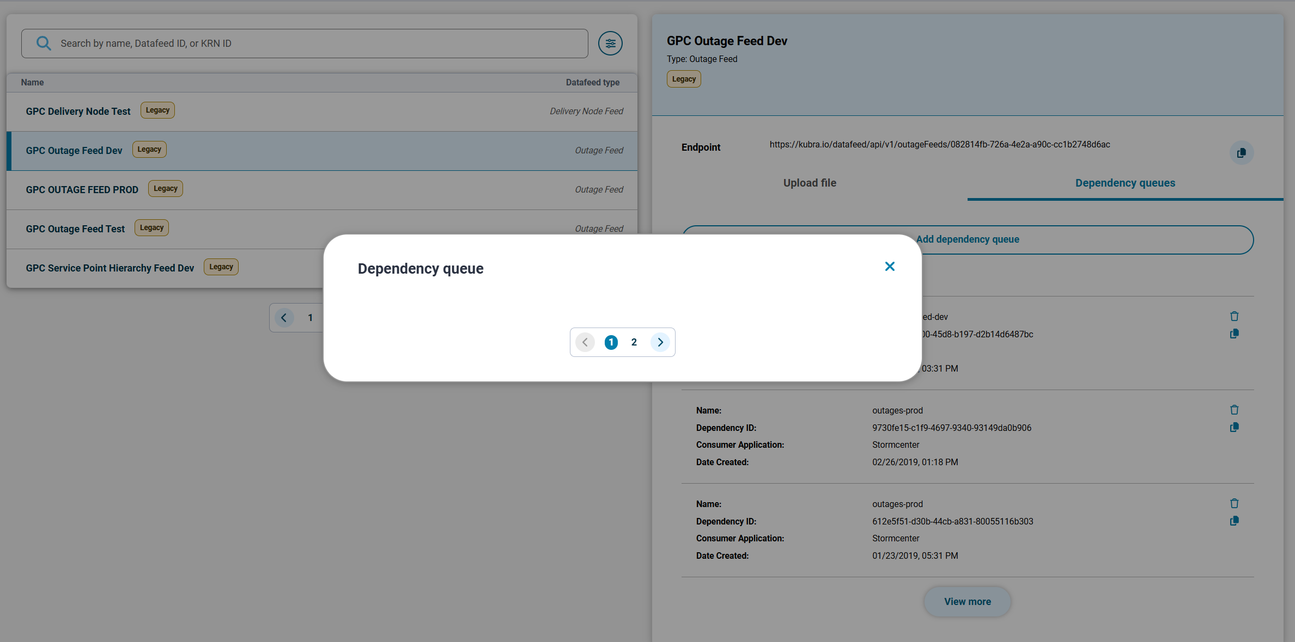
- Who: Krunal Kantrodiya
- What & Why: For any Datafeed if there are more than 3 items under the Dependency queues tab, and “View more” button is clicked then pop-up window comes but it is empty. We usually don’t need to use this feature on regular bases but recently as a part of one ticket I came to know about this bug when my desired queue was not listed and can’t find it through configHQ. I had to make api calls and get the details from there. Therefore, it is not a blocker for us because we rarely use these details, but yes there is some opportunity for improvement.
Complete: Aug 14th.

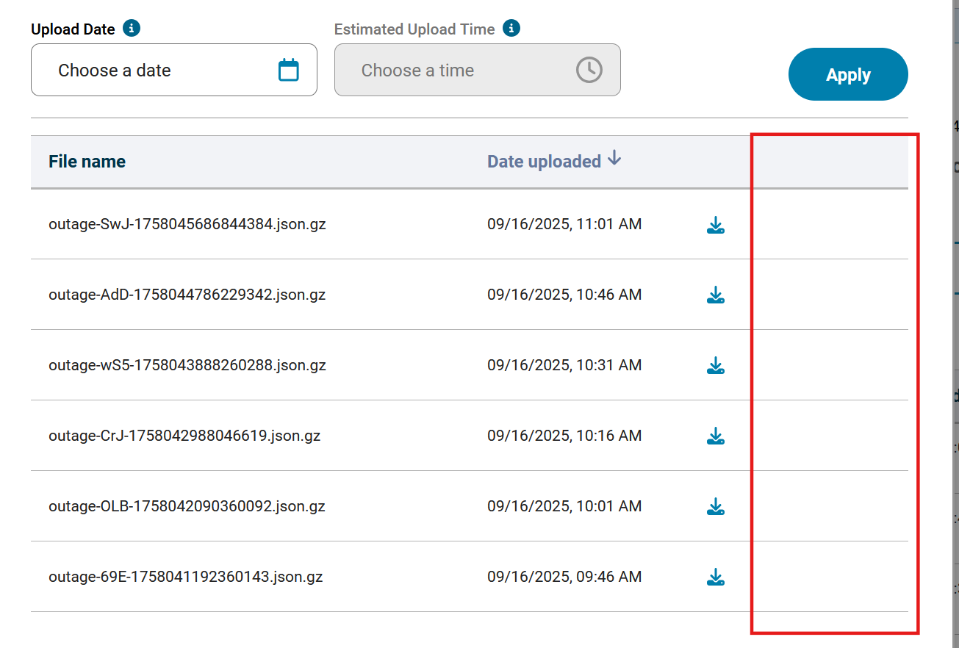

- Who: Logan Garcia (cc: @Huapaya, Luciano )
- What & Why: There are times where clients will send very large outage files or very small outage files, which is useful for both client solutions and the support team to see. Currently, we need to download each file to view the size.

- Who: Akkshaya Gopalakrishnan (cc: @Huapaya, Luciano )
- What & Why: Can we get a refresh option to just reload the file in configHQ? Currently we need to refresh the whole page while waiting for receiving a file and this resets all the search filters

